Brute Syndicate
Volume 2
By: KD Emanuel

Emanuel & Bass Publishing Company, LLC

Man, Let me tell you a Story.
A Short Story in fact.
-KD EMANUEL

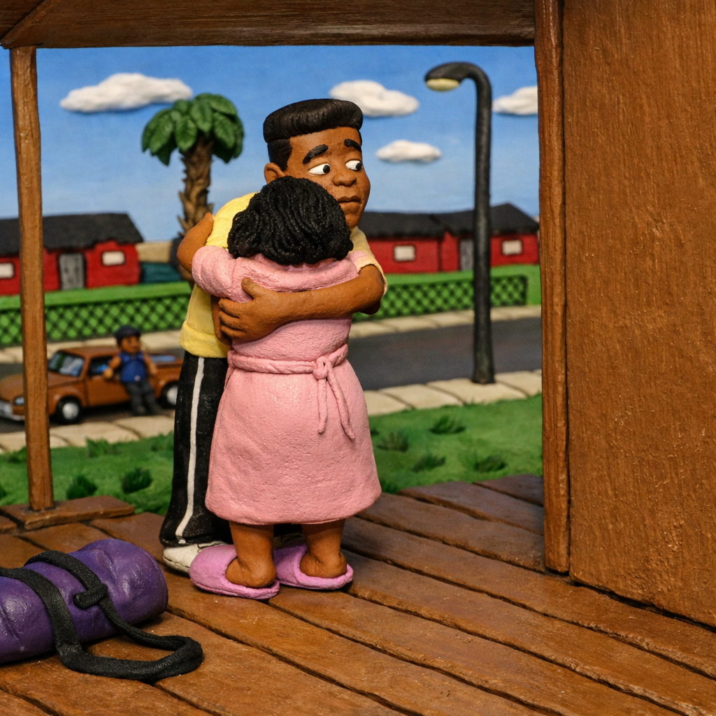

Dinner was just as good as Brian expected. His welcome home was nice and he began to relax. Even though he didn’t want to return, there were some perks—like a home cooked meal. The one thing Brian loved more than anything was a family that tried to take care of each other and this one strived to do just that. Uncle Spaz & Auntie Suzie were always there for him. As many times as he thought he failed in life, he had no doubt his family would always be there with open arms. He had hoped college would be the path to a better life for him and his family. He wanted to take his aunt and uncle away from Bunnell as much as he wanted leave himself. Whether they would actually move away was another story, but his vision in life was to make it out of Bunnell and bring his family with him. He would do whatever it took to make their lives better and return the favors they had generously bestowed upon him.
Streeter ate more than his stomach could handle so he took a break, leaned back in his chair and happened to look up on the wall. The hanging picture of a somewhat familiar face caught his eye and he stared at it for a while.
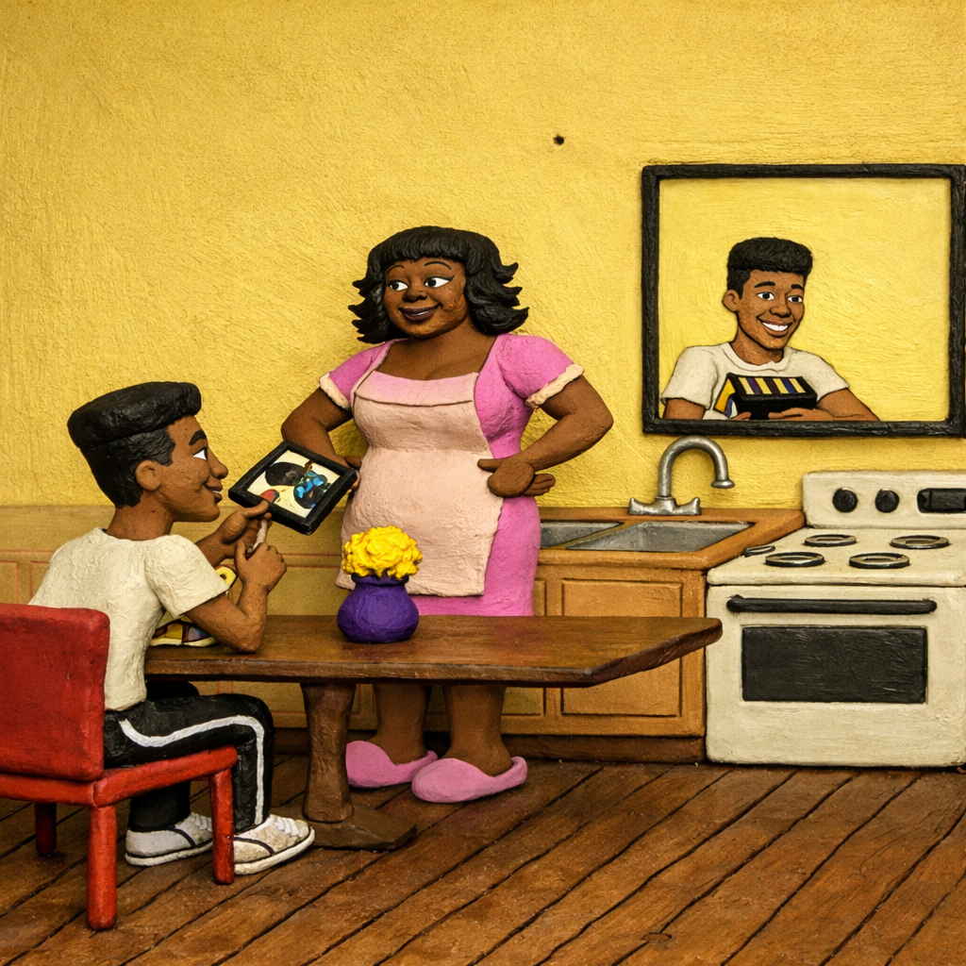
Aunt Suzie noticed his moment of recollection and said, “We got that out of the cabinet months again, Streeter. It’s your dad when he was about the age you are now. He was a handsome man, wasn’t he? Oh, how he would talk about having a son. He wanted to teach you how to do so many things. He couldn’t wait until you were old enough to play basketball or catch the football with him. He loved you so much. We loved him too. He was a good man, Streeter.”
“Yeah, I’ve heard.” Brian said with a smile as he looked at his aunt.
She shoved him in the shoulder. “So, our boy has come back home with sarcasm on his lips,” she said with a laugh.
Brian returned to eating and devoured everything on his plate, rinsed it off and gave his aunt a kiss on the cheek. “I think I’m going to go wash up. It’s been a long day. I’m a little tired.”
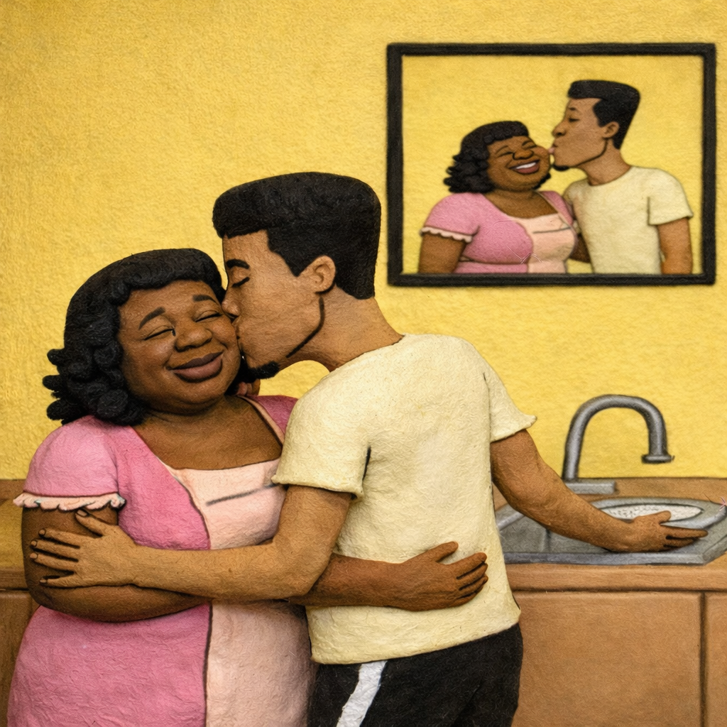

“Sure you are, Baby. You go on and wash up. We’ll see you in the morning.”
Brian wasn’t as tired as he let on, but after the last week he didn’t want to get into the discussion about how great his father was. Everyone knew he was great man and when around Streeter, everyone made sure to emphasize it. Streeter’s dad was much into the well-being of the neighborhood in general, which allowed him to be cordial with the good and bad seeds in the city. They expected Streeter to be as much of a man as his father was. The only problem was Streeter wasn’t so sure he could live up to their expectations. He laid in bed pondering it all and eventually drifted off to sleep after hours of staring into space and questioning the decisions that brought him back to home.
“Streeter!” Wake Up! His aunt yelled from living room.
Brian rolled over in bed and glanced at the clock. “Damn, it’s 6:30 in the morning,” he mumbled to himself.
Another shrill echoed through the hallway, “I need you to bring me to work and you need to go off looking for a job.”
“Right now?” he yelled back, half asleep and partly confused.
“Breakfast is on the table. We’ll leave in twenty minutes.” His aunt’s response reminded him of their early morning routine back when he was in grade school, which seemed to always give him the motivation to get moving. He knew if he laid down any longer, the anger of his aunt’s voice would sure get him moving.
Brian stumbled from his bed and slipped on a pair of his cleanest “dirty” jeans that appeared to be void of stains at first glance. He put on a shirt that had been hanging in the closet and overdosed himself with body spray. Within a few minutes he was plucking a strip of warm bacon from the pan. His aunt ran by him and grabbed her purse from the chair.
“Why do I have to look for a job today?” Brian asked between bites of bacon. “Because you need the money,” his aunt replied. “You need to stay above water.” She sighed, “Although with the economy the way it is around here, you might have a hard time finding anything.”
“Maybe I was better off couch hopping in the city, panhandling during the day, you know as a bum. I’d make a lot of money that way. Way more than I would here.”
“Very funny, smart ass, “Aunt Suzie shot back. She looked at the clock hanging on the wall and screeched, “Oh dang it, Streeter. We’re late and you’re busy making jokes. Throw some food in a napkin. We have to go.”
“Where’s Uncle Spaz?” He’s already gone to work. He leaves at 4:30.”
“Dang, never mind then.” “Never mind what?”
“I was going to ask if I could work with him, but I know I couldn’t get up that early. “Streeter felt a lecture coming as the words left is mouth.
“You know, Streeter. You’d be surprised what you can do when you have no other option.”
Streeter and his aunt gathered their things and left the house. The ride to his aunt’s job was pretty quiet. Feelings of nostalgia came over him as he drove through his old community. Memories began to flood his mind concerning the places he used to go and the friends he used to run with. Streeter was beginning to see some of the positive aspects of being back, like reconnecting some of his childhood friends he lost touch with after going off to school.
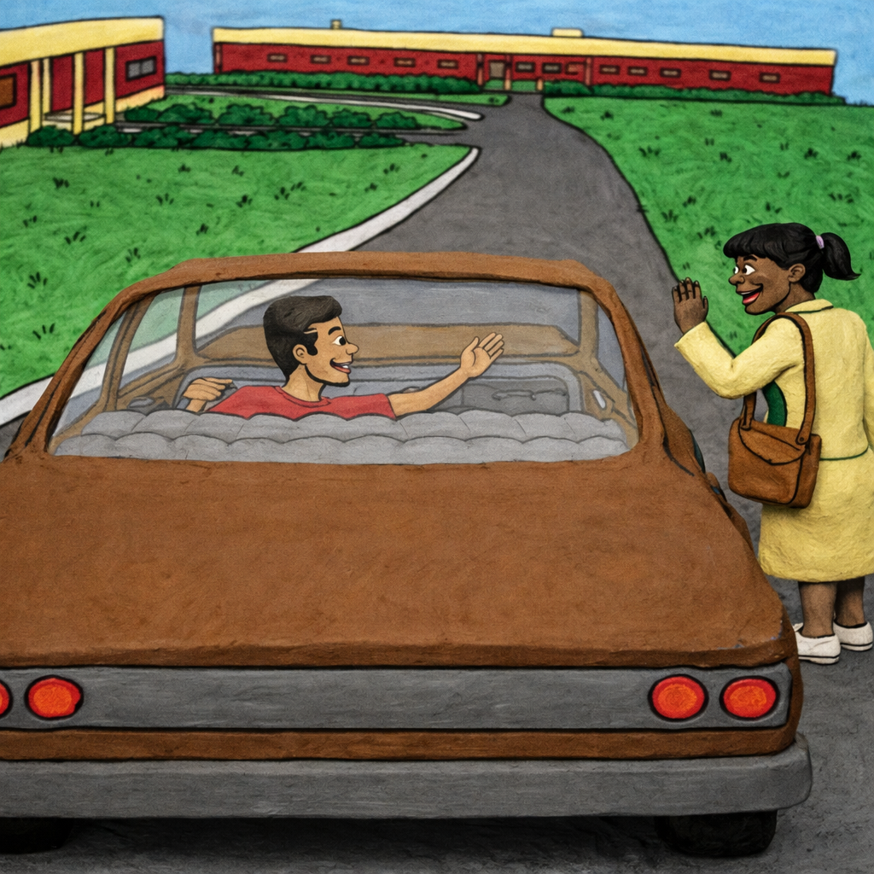

Streeter pulled up to the nursing home where his aunt worked. Before she exited the car, she told him, “Well this is what you decided to do, the real world ain’t easy and sometimes you have to do things you didn’t think you could do, or didn’t want to do in order to make things work out. Don’t forget that. Don’t ever let your life become too easy. That’s how people get into trouble. “There was a serious look on Auntie Suzie’s face, something Streeter wasn’t used to. He didn’t know if it was a warning, or sarcasm. Either way, she wasn’t smiling.
“Alright. I’ll remember that. No easy money,” he said as he smiled.
She patted him across the cheek, a little harder than he would have liked and retorted, “Good, now you go take a look around the corner. There’s a construction company over there that I think is hiring. Maybe they have something for you.”
Brian went to the construction company his aunt had referred him to, but apparently he was reading the sign wrong that read Now Hiring because they told him they didn’t have a job for him. He spent the rest of his day driving around and looking for a job. He could tell simply by the dusty store windows and the limited cars moving in the streets that he wasn’t going to find anyone hiring. In fact, he wasn’t even sure he wanted a job out here. Maybe he should have hung out around his old college campus. At least he would have been around the more familiar surroundings he had gotten used to over the last couple years.


Brian became frustrated with his fruitless job search. He only had a couple hours until his aunt needed to be picked up from work, so he figured he’d go seek out some familiarity. He pulled his car into a tight turn and drove two blocks in the opposite direction. He pulled over to his right where an old green bungalow sat. It was small and weathered, but it brought a smile to Brian’s face. His friend Kareem had grown up in the home and Brian had been there countless times, but it wasn’t until he went to college and then came back that he could see some of the beauty in the decrepit place. The yard was tiny and surrounded by a chain link fence. Brian was surprised that the grass had been recently mowed. He didn’t ‘even know if Kareem still lived there, but he decided to find out anyway. The two steps up to the small porch creaked as he made his way to the door and knocked. He waited almost a minute.
“Who there?” came a deep, firm and seemingly angry voice from inside. “It’s umm, it’s Streeter.”
“Streeter?” The voice parroted. Suddenly, the thick door flew open to reveal his familiar, yet changed, friend. The young, guy Brian remembered from high school was now tall and broad shouldered. Despite the shabby appearance of the house, Kareem was dressed to a tee, sporting a nice little temp fade, bright white Nikes, dark jeans and white tank top. A chain with an African pendant on it hung around his neck.
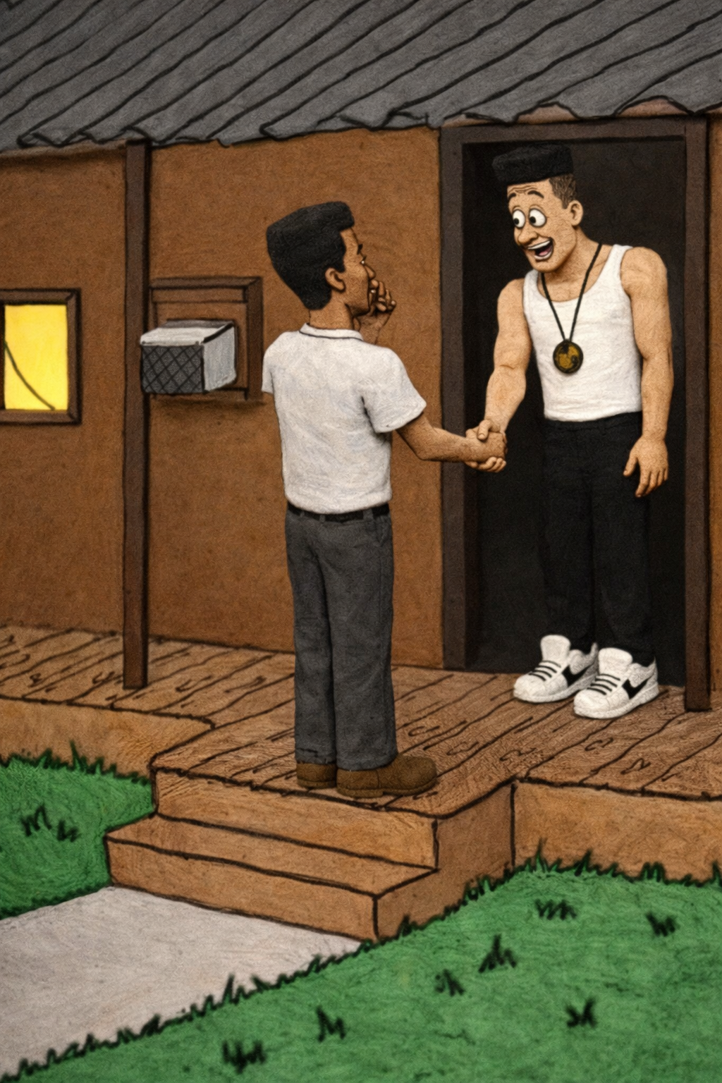

Kareem’s face lit up in a wide smile and he lunged forward, grabbed Brian’s hand and pulled him to his chest where he gave his old friend a firm pat on the back. “What up, boy? What the hell you doing here?”
Brian walked inside and filled Kareem in on everything that had happened. He told him that he’d been looking for a job and thinking of going back to school for his master’s degree, maybe even a job.
“That’s good,” Kareem said, shaking his head in the affirmative. “I’m glad to hear that’s what you’re still looking at. At least one of us gonna make it.”
Brian nodded at the comment, which made him feel awkward. Then he said, :Yeah, well, we’re going to make it.”
Kareem smiled, “But, look around. I gotta take care of my grannie now. Can’t leave her around here alone with all these niggas running around.”
“We used to be those niggas.”
Kareem hesitated and smiled at Brian, “Yeah, we were.”
They were quiet for a long time after that, each one captured by a flood of memories, hopes and dreams. The atmosphere grew thick and uncomfortable. Brian wondered if he should make up an excuse to leave, or if the was what Kareem wanted. “Hey, what ever happened to Tammy?” he finally asked to break the mood.
A huge smile crossed Kareem’s face as he said, “You talking double-dee or toothpick?”
“Do you have to ask? Double-dee.”
“Oh, man you’ve got to hear this…”
Once they started talking about girls, it was like they were sixteen again. Another hour passed before the conversation became stale again. Brian nodded to a photo on the wall of Brian, Kareem and their friend Tony. “What’s Tony been up to? Is he still around?”
“Yeah, he’s around. Probably on 13th Street. At least he should be.”
Brian nodded, wondering if he should even try heading down there. He recalled how 13th was nothing but trouble. It was a hotspot for drugs and soliciting. He remembered the Trap House he used to go by as a kid. As hesitant as he tried to be while sneaking around there, it always scared the shit out of him. Cop cars ventured down the streets in at least thirty minutes intervals, and you’d think that would stop activity. However, it only ceased during the minute the car was driving pass. Once the cops passed, the streets crawled with illegal activity again.
Brian stood up, “You know what? I think I might run down there, drive around and see if I can find Tony.”
Kareem nodded, his wide smile coming across his lips again, “I’ll roll with you, Streeter. See what that nigga up to.”

